Rocket Launch

Prepared by Johannes Beer, July 25, 2013

Challenge:

Create an environment with a drawn rocket which includes four buttons. The buttons should have the following functions:
- Launch the rocket toward the sky with repeated button clicks. Each click will move the rocket higher up.
- Launch the rocket with one button click. The rocket will move at a steady predetermined rate.
- Launch the rocket with one button click. The rocket will move at a rate that is adjustable by the user. This requires the placement of a Watcher variable on the form in addition to the button.
- Reset the rocket to the bottom of the form ready to be launched again.

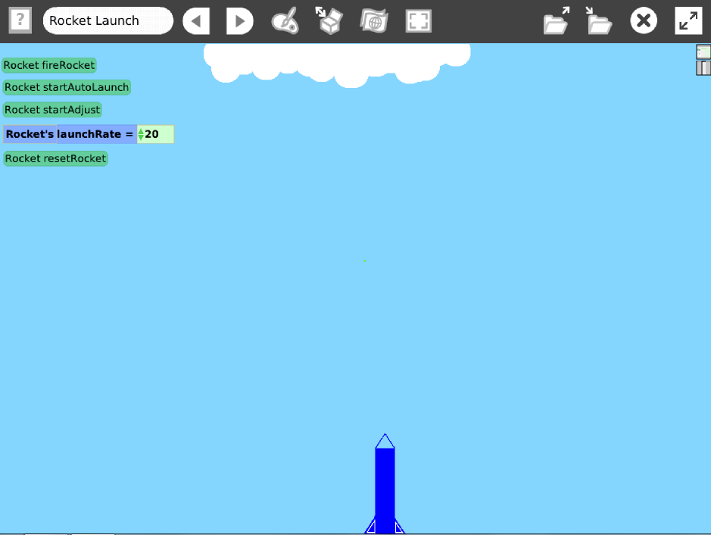

Things you will need to know:
- How to create a button from script.
- How to use, pause and launch a timer script.
- How to create and use a variable.
- How to create a watcher variable.
- How to pause a running timer script.

Extensions:

- Create a button that that will more accurately recreate the flight of a launched rocket by flying slower at first and then gaining speed.
- In addition to the speed change mentioned above, arc the rocket either left or right has it gets higher.
- Rocket automatically resets when it hits the clouds.

How to do it:

First draw the rocket and clouds. Then move the rocket to the bottom of the screen and note the y-position. This will be the y-position used in the Reset button. All of the scripts will make some adjustment to the y-position of the rocket.

To get a button, create the script and then click on this image and select, “button to fire this script”. To get Watcher variable, first create the by clicking on wide V on the top viewer, then drag the viewer variable onto the form.

Buttons 2 and 3 will require two scripts each. One script will have a paused timer to move the rocket and other script will start the script to unpause the timer. Note: the Start and Pause script can be found by going to the Rocket viewer and search for Start and Pause.

Button 4 (Reset) does three things. It resets the y-position of the rocket and pauses the auto launch buttons 2 and 3.

